IDA Masters Assignment

Vast Challenge 2015

Mini Challenge 1

We’ve converted CSV files to RData files, as these are easier to load and manipulate data for RStudio.

We tried to parse GPS data and the location of the attractions from the provided data. Appearance/check-in of an individual was counted at all attractions. And if this pattern of check-in was matched with another individual, both were termed as a group.

As per this assumption, we tried to draw histogram based on the size of the group. Upon initial view, groups can be clubbed into small, medium and large.

Further we tried to classify group activities based on day(Friday/Saturday/Sunday) and various attraction involved.



We analyse the visitors in large groups from Friday, and visualize their behaviour in the sequence view. Each visitor is represented as a horizontal line and the attractions they participate are color-coded by types of attraction. For example, the “first row” group, is the only group who does not go to the show at 15:00, and relatively large gray gaps between attractions suggests that they spend more time walking between attractions.  This group leaves the park around 18:30.  Another insight from this representation is that we can find some variations within a large group.  For instance, about a half of the “last row” group goes shopping between a beer garden and a kiddie ride around 11:00. Since none of the groups use the Information & Assistance, we hypothesize these groups may have a tour guide or someone very familiar with the park.  By examining per attraction type, we can characterize a group better, for example, the “second row” group goes to Beer Garden 7 times throughout the day.



Below figure shows the sequence view of large groups on Saturday. On Saturday, every large group goes to see the Grinosaurus Stage at 15:00. It also appears that groups who arrive early spend more time at the entrance. Perhaps, the park could try to minimize the waiting time to handle the arrival of large groups in the early morning. Another general trend is that people in large groups tend to shop at the end of the day.



Probably because of the partial closure on Sunday, the large groups on Sunday don’t have the distinctly common behavior among them.



We tried to find pattern in activities of the various groups across 3 days. We created path plot for each activity over 3 days. We found out that

First : the Craighton Pavilion and the Grinosaurus Stage closes after 12:00 on Sunday. Second : Very high number of people visit Leggement Fix-Me-Up at 14:00 on Friday.

Third : Maximum number of people visit park on Sunday , and decreasing count on Saturday and then on friday.

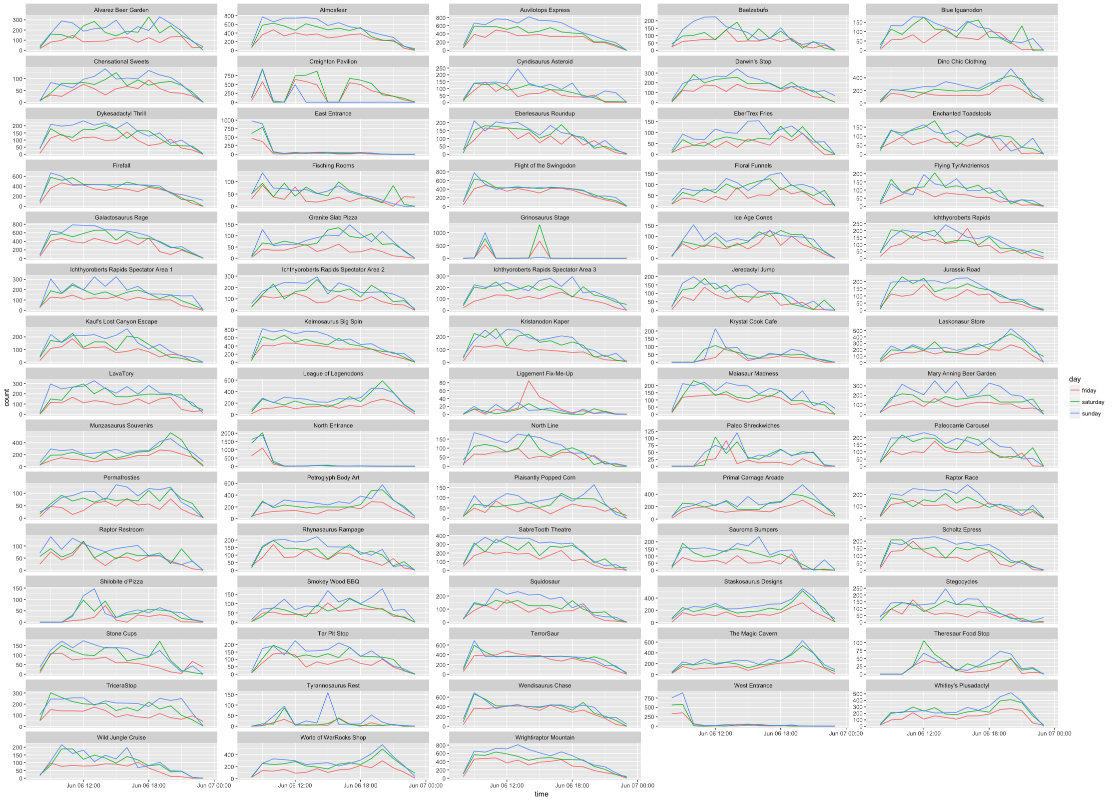

We even created path plot for time spent on each activity, from the collected GPS data.

